# 3. Result

## 3.1 Study area

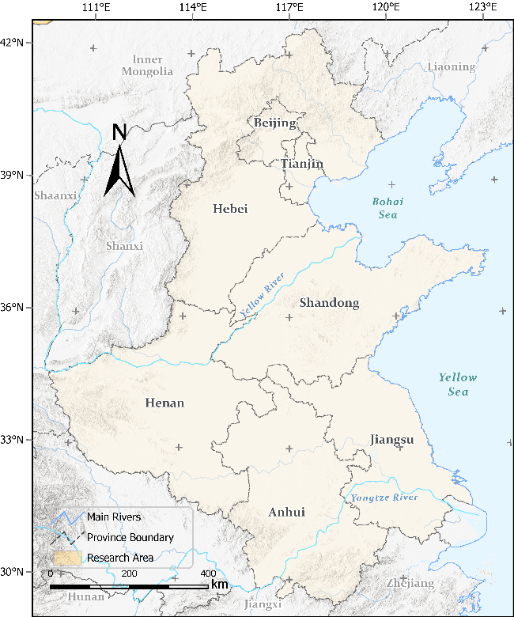

The study area (figure) includes five provinces (i.e., Henan, Hebei, Shandong, Anhui, and Jiangsu) and two municipalities (i.e., Beijing and Tianjin), which covers the North China Plain, spans 780,000 km2 and homes to over 450 million people (ref). This area is one of the fastest urbanized regions in China that have tripled the built-up land coverage rate from ~5% in 1990 to ~15% in 2020. This region is crucial to China’s economic development and holds a strategical role to safeguard China’s food security (ref) because over one third of national gross domestic product and grain supply was generated there. The tension between urbanization and farmland conservation in the study area requires accurate and spatial-explicit understandings of the future urban development to address the challenges of food security, environmental protection, and urbanization in their infancy stage.

## 3.2 Data processing and model training

The

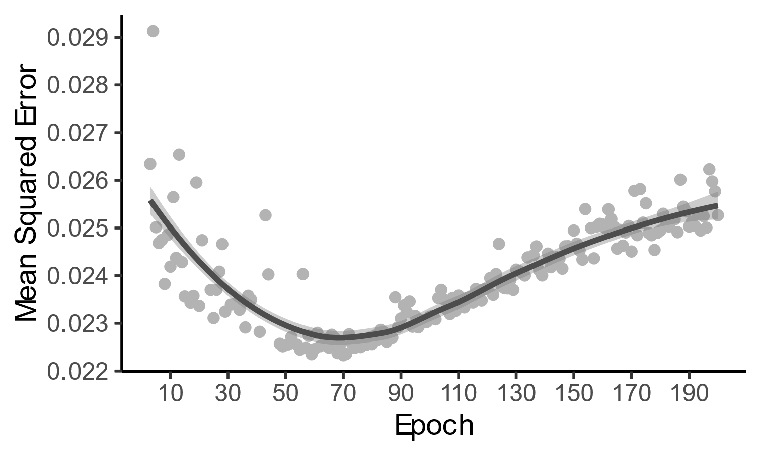

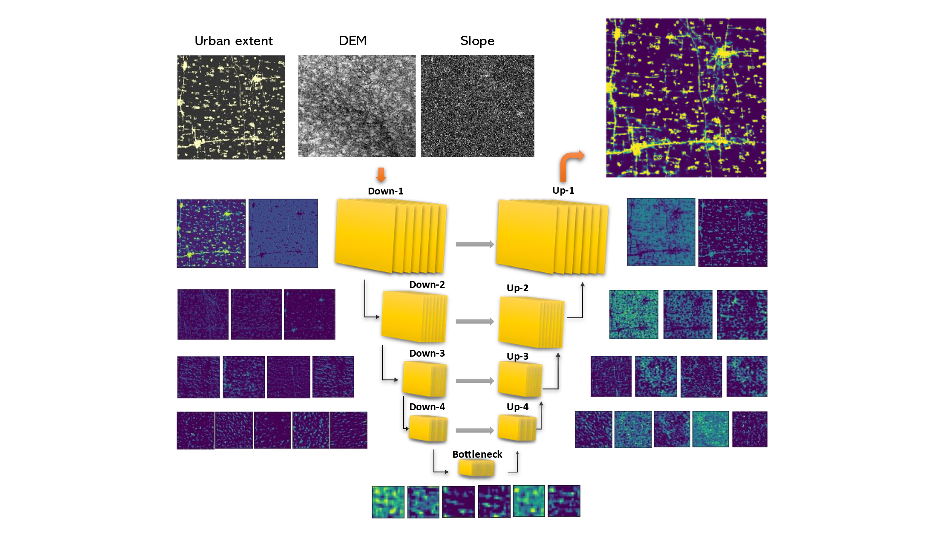

## 3.3 Transition potential

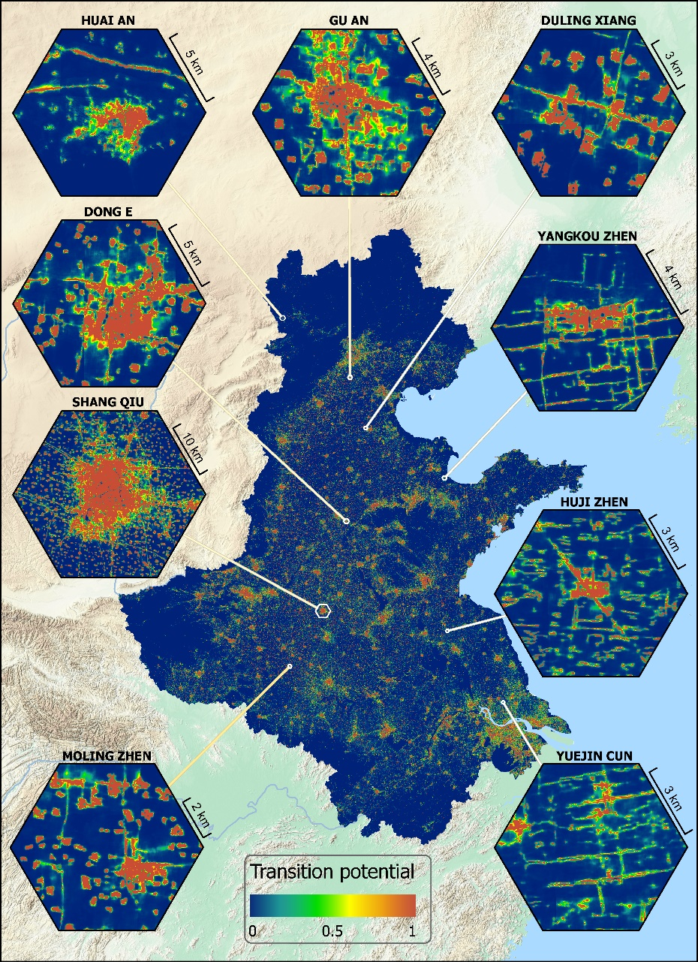

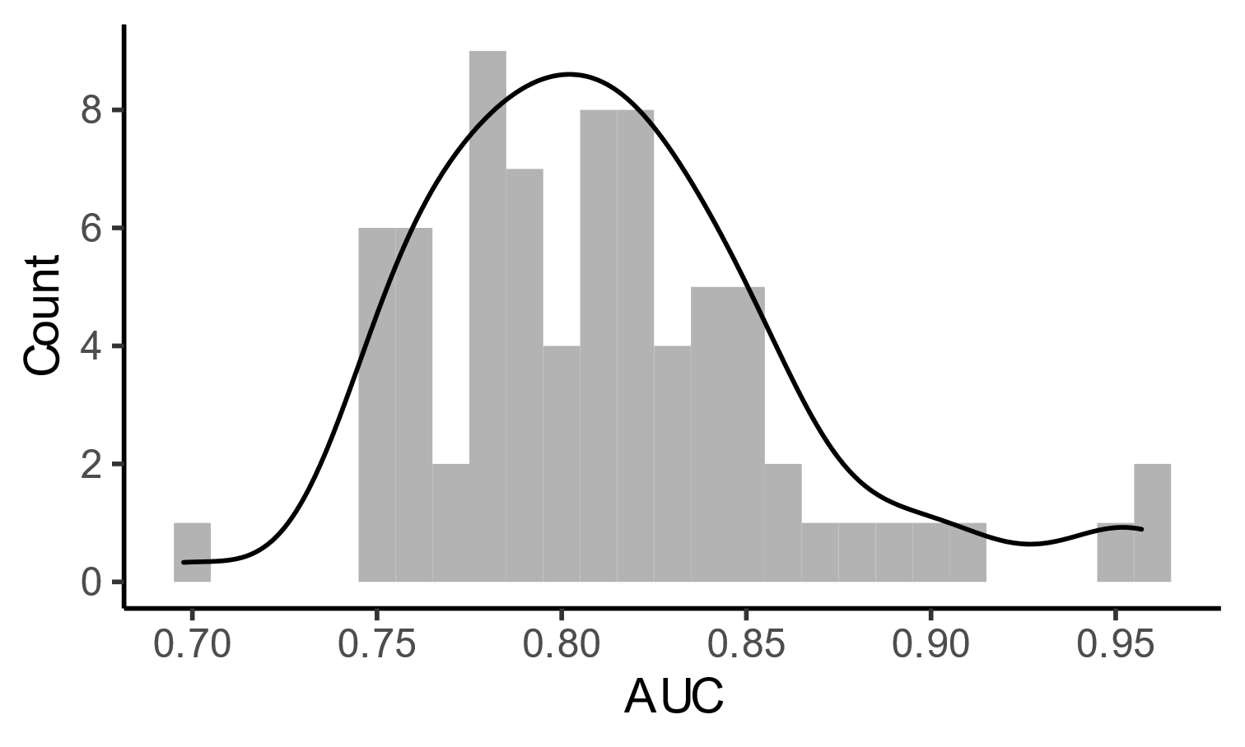

## 3.4 Accuracy

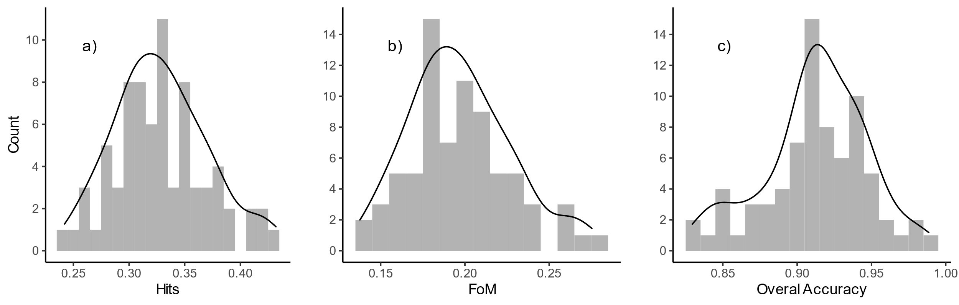

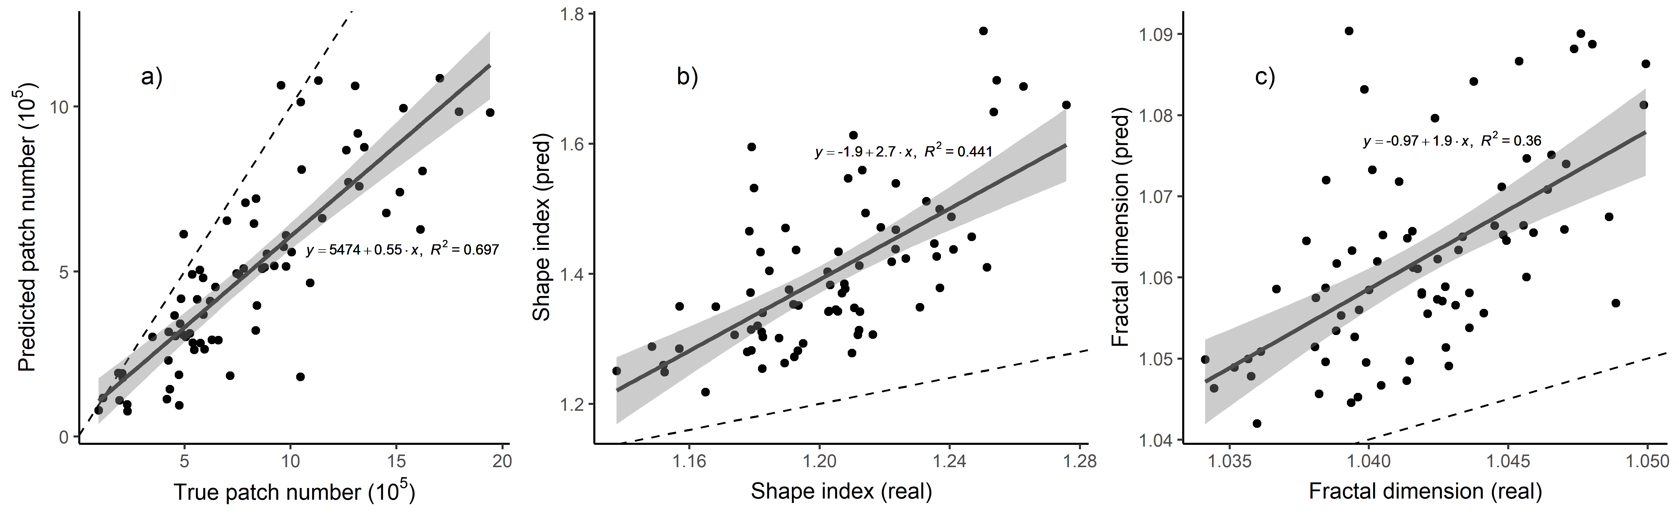

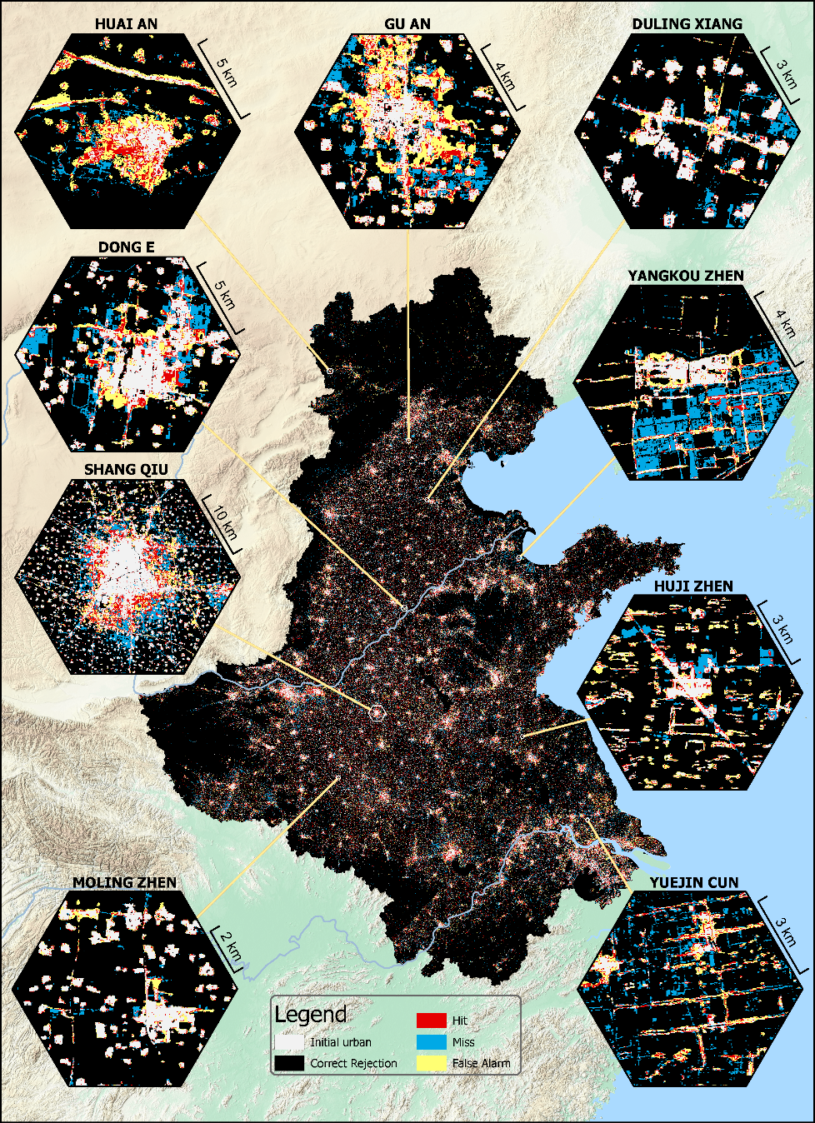

## 3.5 Prediction

